GPS Platform Management--Distributor
- Platform user have 2 types: End user & Distributor, end user account is used by end customer, it only can operate and check user’s own tracking device, the operation please refer the platform operation guide. Distributor account is used by agents and distributors, it can manage the tracking device under own account, such as: create new end user & fleet user, reset password, move device to specify user, update expired date, monitor any device under own account, etc. And this manual is only suit for distributor user.
- The tracking devices have been added to distributor’s account before shipping, and the distributor can not add device itself, distributor only can operate the device under own account, such as: create new end user & fleet user, reset password, move device to specify user, update expired date, monitor any device under own account, etc. The tracking device is active by uploading tracking to website, after active the device is given 1 year expiry date automatically, if the device is given life time free platform service charge, the expiry date will be over 10 years, if the device is given 1 year expiry date, then the distributor can update the expired date later.
- Note: Before shipping please select your device is life time free platform service charge or only 1 year free platform service charge, the default is life time free service charge, otherwise you need contact us later to delete the device and re-add the device later, this maybe delay 2-3 days.
Note: in the following “Click” means click once with mouse left button.

Distributor Account Login
Vsit: www.999gps.net with PC, the login page will display, this login page is same with the normal end user login page, language can be selected:
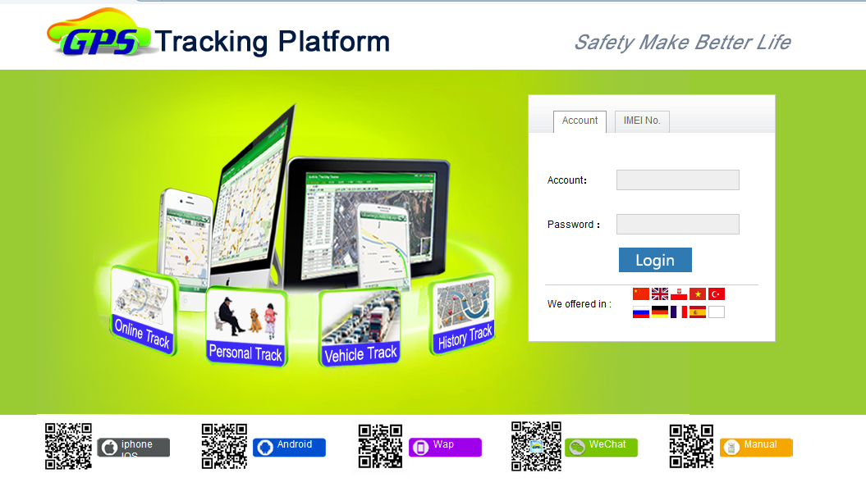

Input the distributor account name and password and click “Login”, the system management page will display, it is different with end user, the end user will go to monitor page directly. At this system management page, distributor can operate own device , also can go to the monitor page to check the end user device.
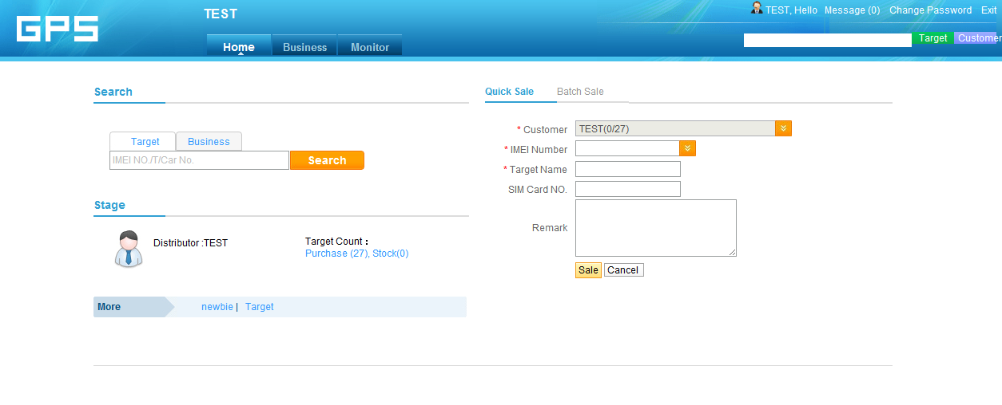

Quick Search
You can search the customer account or device in the right top corner frame or the middle left search frame.
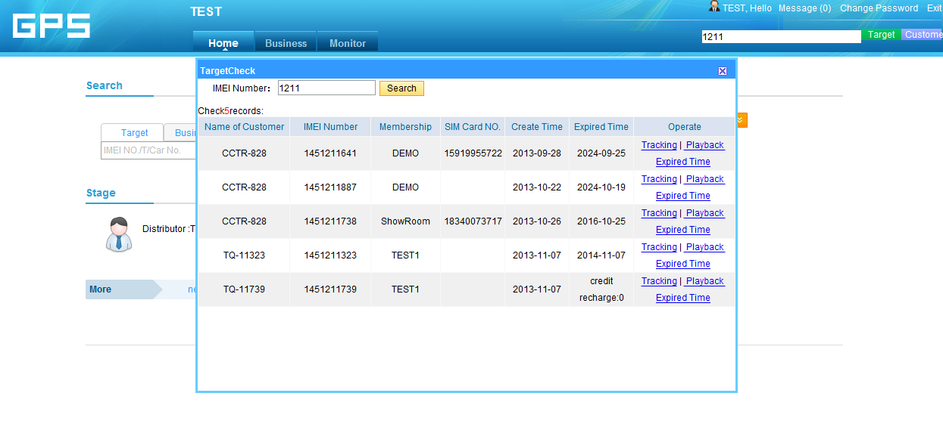

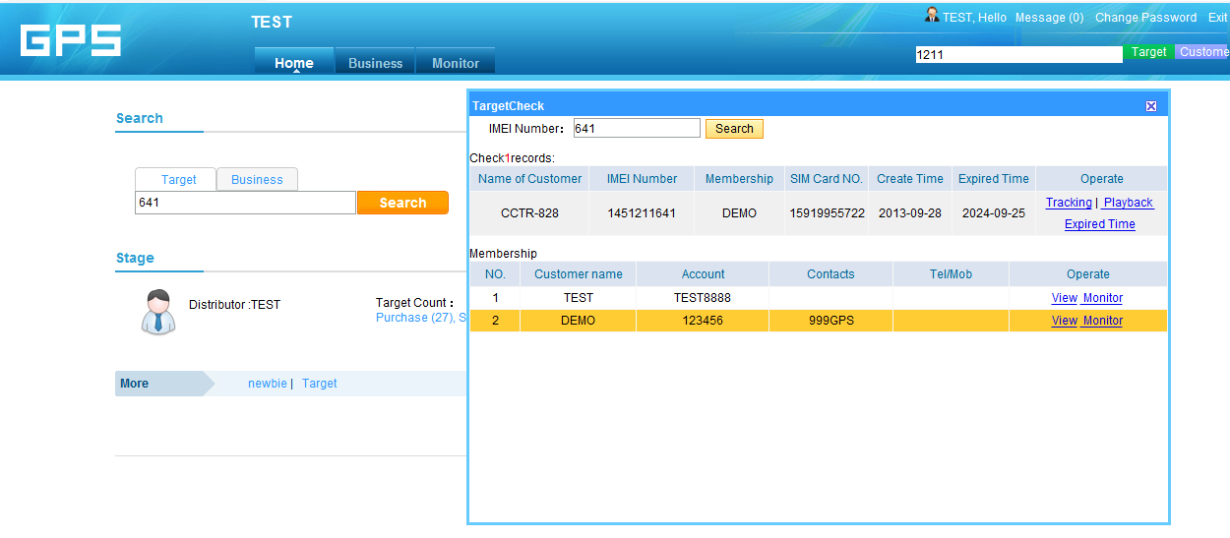

Note: In the search frame input the key word or digital word, click the “Search” menu, the pop up window will display the search result, after you search the device, you can operate the device, for example move to other user account or fleet, reset password to 123456, update expired date, change the account setting, tracking this device, check history tracking etc.
Business Page
Click the “Business” on the top menu bar, the business page will display, the page is as follow:
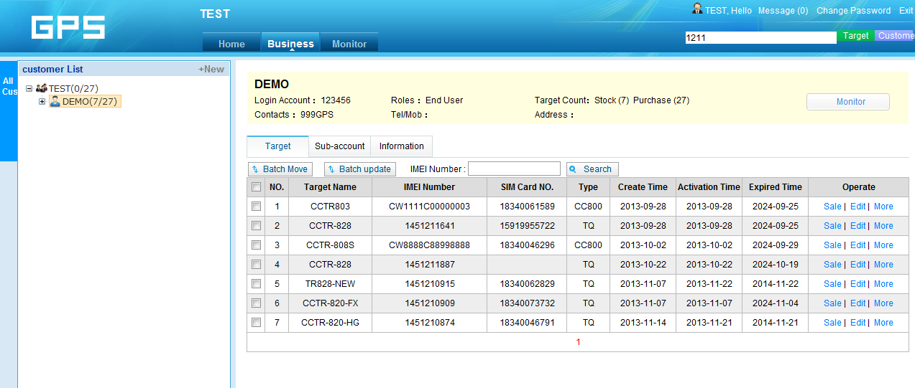

The left window is a customer list, this will list all the customer under the distributor account, click the customer name in the list, the customer detail information will display in the right window. Including device information, sub-account information, the distributor account information etc.
Note: the distributor account contact information can be display to sub-account, please fill your Contact name / Telephone or mobile phone number / Address, if this information is not filled, maybe the sub-customer can not find distributor to pay for charging & updating expired time.
Customer List
All the customer under this distributor will display in the list. Click the name of customer, the sub-customer will display, including how many device under this customer.

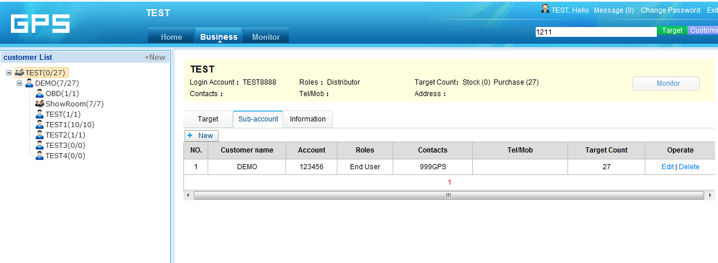

Add New Customers
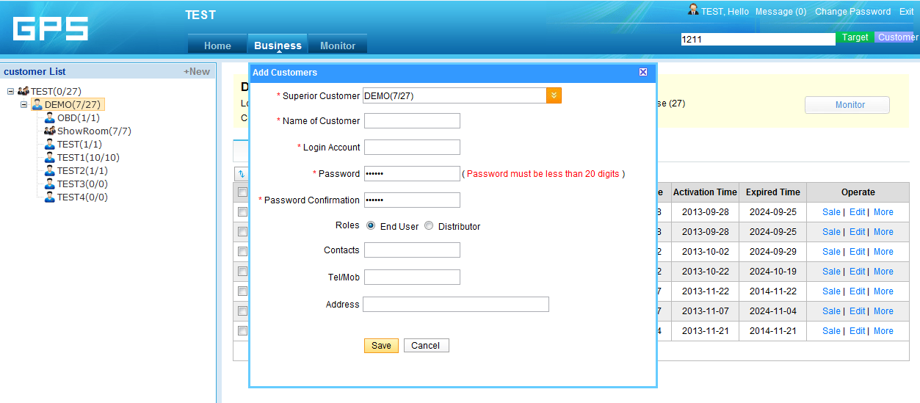

Click the “+New” on the right top corner of the customer list window, an “Add Customers” menu will pop up, select the upper account name you will add, for example add a new customer under DEMO account, you should select the superior customer is DEMO, name of customer is the display name in the left customer list, the login account is the login name of this customer (the name of customer and the login name can be different), the default password is 123456, the roles can be select end user (End user only can operate own device) or distributor (Sub-distributor, can management the device under the sub-account), and the contacts / tel/Mob / Address is the new customer contact information, Click “save” will create the new customer. After create a new customer, move a device to this customer, this customer can tracking this device.
Customer Management
Click once the customer name in the left window with mouse right button, a menu will pop up, Add customer / Manage Customer / Delete Customer / Reset Password menu will display. Click these menu can operate the command.
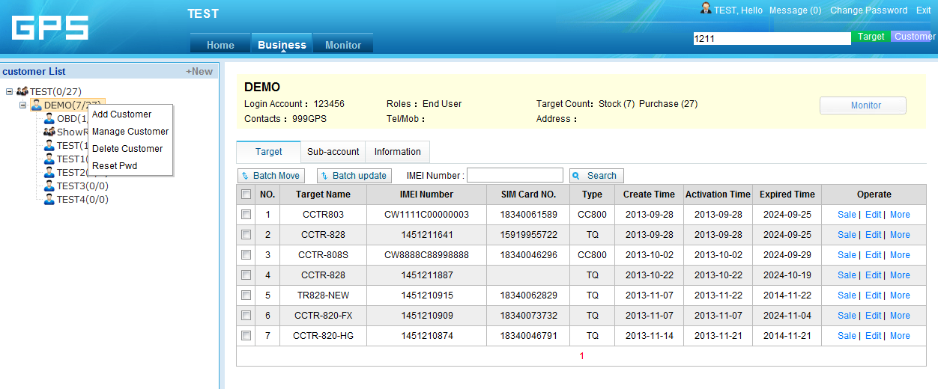

Display Customer Information

The right top is the customer information, Name / Contact information etc.
Change Customer Information
Click “Business” and click the “+” in the front of the customer name in the command list, the sub-account name will display in the list, then click the customer name and click “Information”, the customer information will display like the following page:
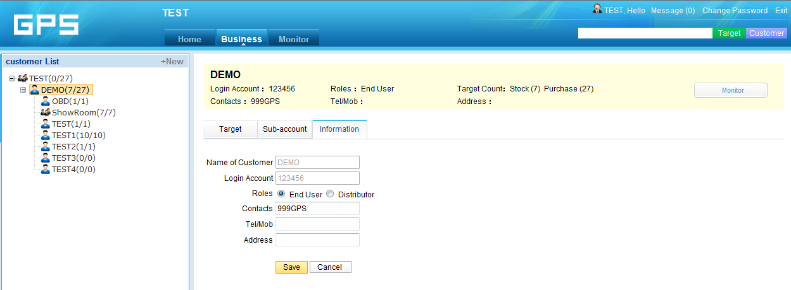

In this page, customer information can be changed and update. Like Contacts / Telephone / Mobilephone / Address etc. Click “Save” to save the changing.
Target / Device Management
Click “Business” and click the customer name in the command list, and then click “Target”, the target device under this customer will display, then the operation like move / sale device, change the device information, change expired date, reset the device password can be done.
In the target device list, the create time is the time of super user add the device to the platform, and the activation time is the time of the device upload the location for the first time (The device is active by uploading location to platform), and the expired time is the expired date of the platform for this device. Sale / Edit / More menu can move / sale the device to sub-account, Edit can edit device information, and More can update the expired date and reset device password.
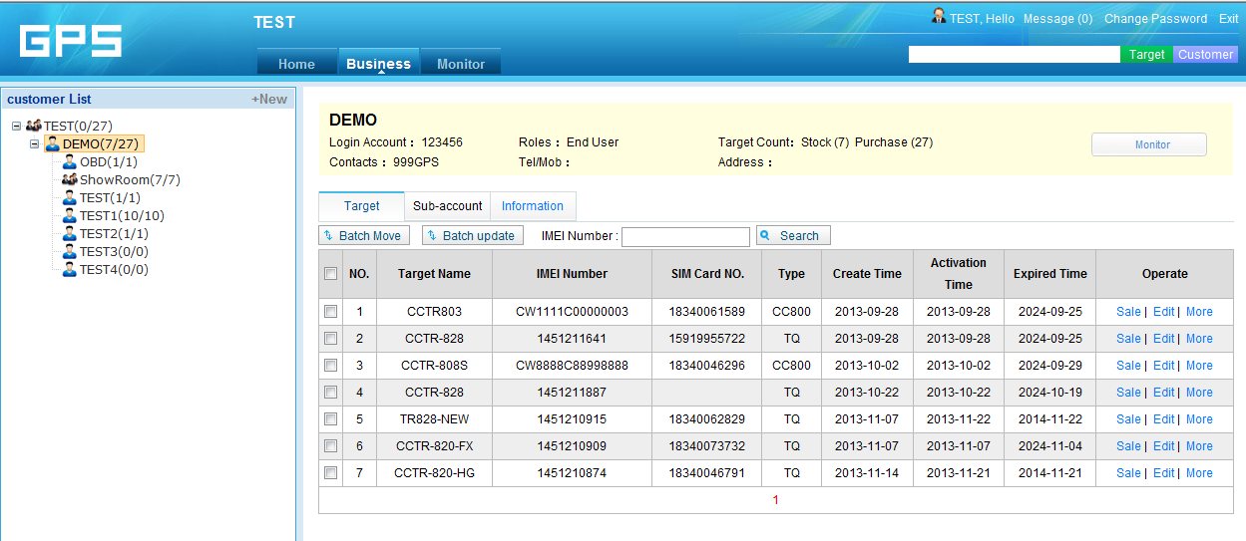

Sale Device to Customer
Click the command “Sale” behind the device in the target list, the sale window will pop up, select the customer name you will sale this device to, you can change the target name, Sim card number, and you can write some remark in the remark field, and then click “Save”, the selected device is sold and moved to the selected customer. This command only operate 1 device one time.
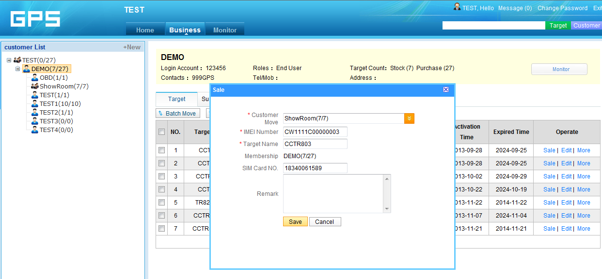

Note: When sale a device to a customer, just create a new account name, and operate the “Sale” or “Move” command to move the selected device to the new account is OK, the device will be active automatically when the device is powered on and uploading location to platform.
Edit Device information
Click the command “Edit” behind the device in the target list, the device information window will pop up, you can change the target name, Sim card number, car plate number, contacts, overspeed alarm speed, contact telephone & mobile phone , average fuel consumption (unit L/100Km , it is used to calculate probable fuel consumption), select device icon display on the map, and also you can write some remark in the remark field, and then click “Save”, the selected device information is changed. This command only operate 1 device one time.
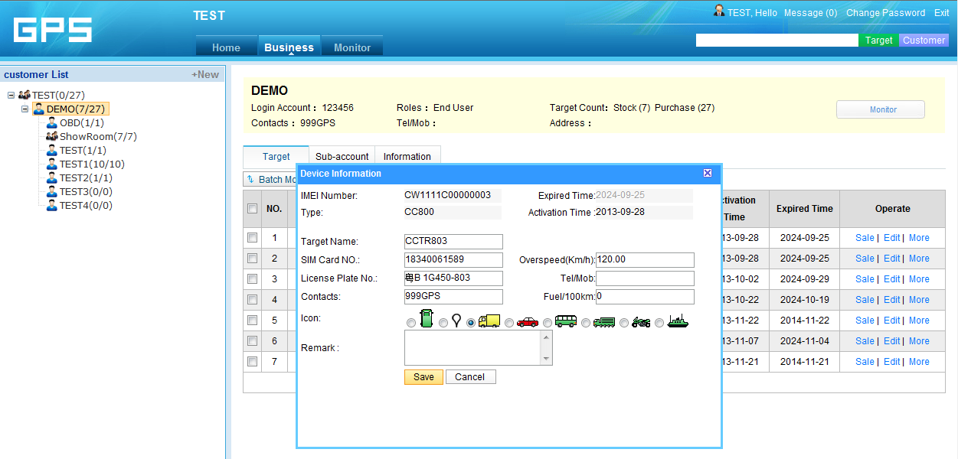

Reset Password of the Device
Click the command “More” behind the device in the target list, a menu will pop up, click the “Reset Pwd”, the reset password warning window will pop up, click “OK” to confirm the operation, and the success information will display. And the password of this device is reset to 123456, user can change the password after login the platform with the IMEI and this password. This command only operate 1 device one time.
Note: The device password is used to login the platform with the IMEI(ID or SN) name, after login, it only can track the single device, this password is not the password used to login the platform with the login account name, use login account name to login platform can track all the device under this account.
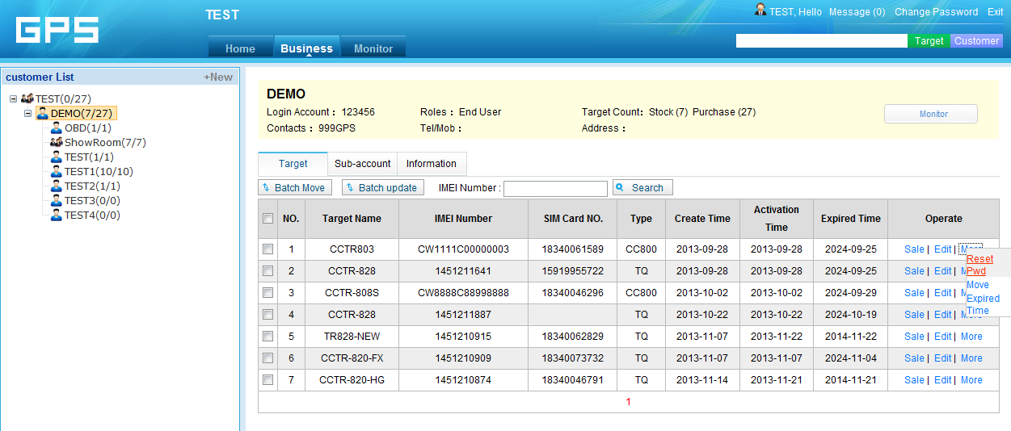

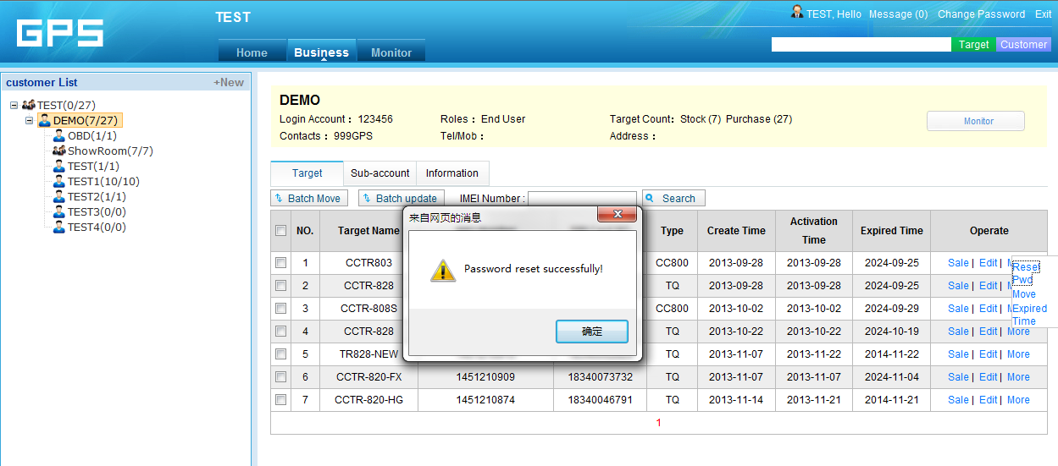

Move Device
Click the command “More” behind the device in the target list, a menu will pop up, click the “Move”, the move device window will pop up, select the customer account name you want move this device to, click “Save” to confirm the moving. Then this device is moved to the selected customer. This command only operate 1 device one time.
Note: The “Move” command and “Sale” command all can move the device to selected customer, the only different is the “sale” command can change the device information, but the “Move” command only move the device to the selected customer.
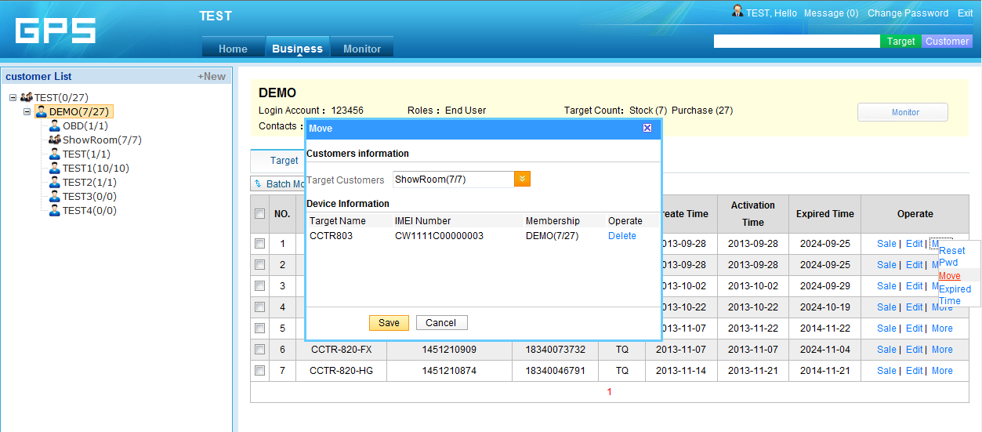

Update Expired Time
Click the command “More” behind the device in the target list, a menu will pop up, click the “Expired Time”, the update expired time window will pop up, select the one year, two year or life long (life time free is 10 years expired time), or you can specify how many days, then click “Save” to confirm, if the device was active, the the expired time will be the expired day month year, if the device is not active, the expired time will add to the “Credit recharge” point, 1 credit recharge point is 1 day, 1 year is 365 credit recharge point, when the device is active, the credit charge point will change to expired day month year. This command only operate 1 device one time.
Note: Before operate the update expired time command, the distributor account should have enough credit recharge point, and this credit recharge point only can be given by superuser of the platform, please contact us or your dealer to get enough credit recharge point.
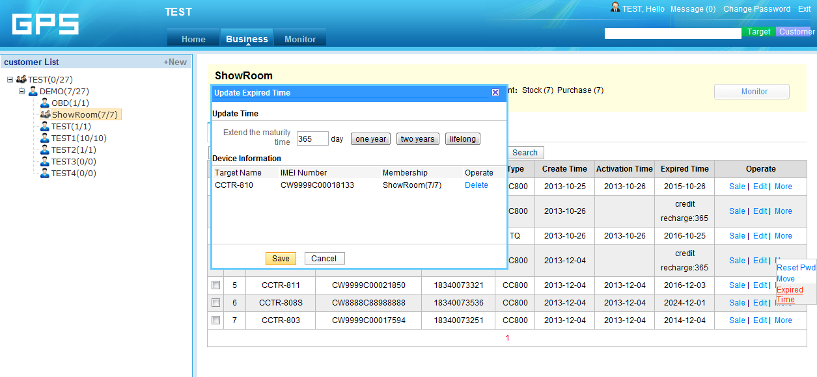

Batch Update Expired Time
Click the frame before the device in the target list to select it, and then click the “Batch Update” command upper the device, the batch update expired time window will pop up, select the one year, two year or life long (life time free is 10 years expired time), or you can specify how many days, then click “Save” to confirm, if the devices were active, the the expired time will be the expired day month year, if the device are not active, the expired time will add to the “Credit recharge” point, 1 credit recharge point is 1 day, 1 year is 365 credit recharge point, when the device is active, the credit charge point will change to expired day month year. This command can be used to update the selected fleet or group devices expired time one time, the function is same with the “Update Expired Time”.
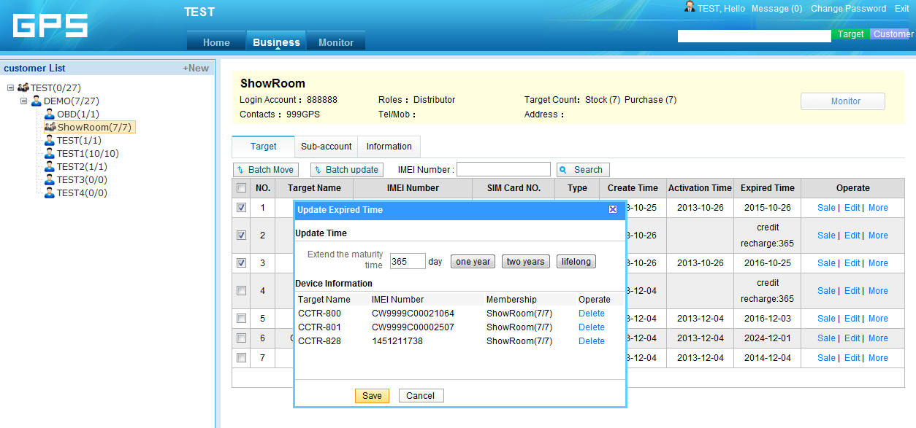

Batch Move Device to Sub-account
Click the frame before the device in the target list to select it, and then click the “Batch Move” command upper the device, select the customer name you want move to, Click “Save” will move the selected device to the selected customer. This command can be used to move selected devices to new fleet or user.
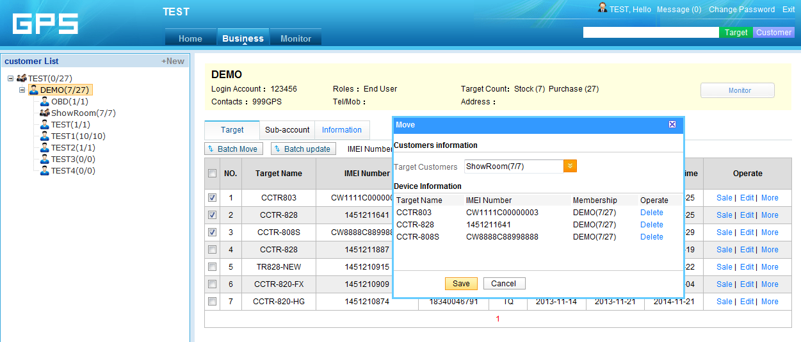

Monitor Sun-account Selected Device
Click the customer name in the customer list to select the customer device you like to monitor, and then click the “Monitor” in the top right of the page, or click the “Monitor” menu in the top of the page, a new monitor window for the selected customer device will pop up, the operation of this page is same with the normal end user, you can check device current location, playback history tracking, export running report etc.
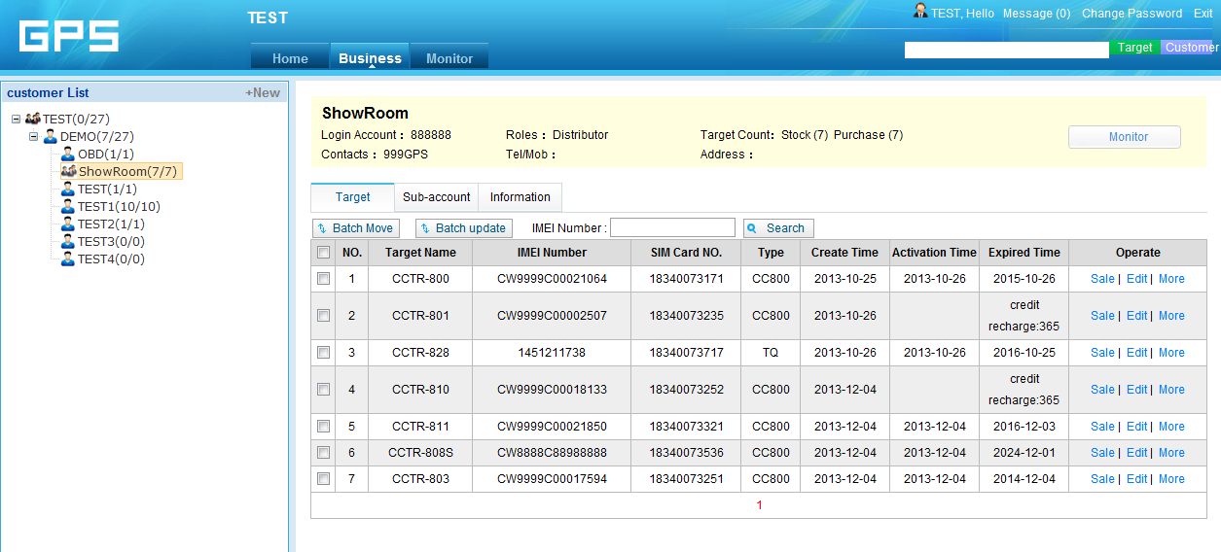

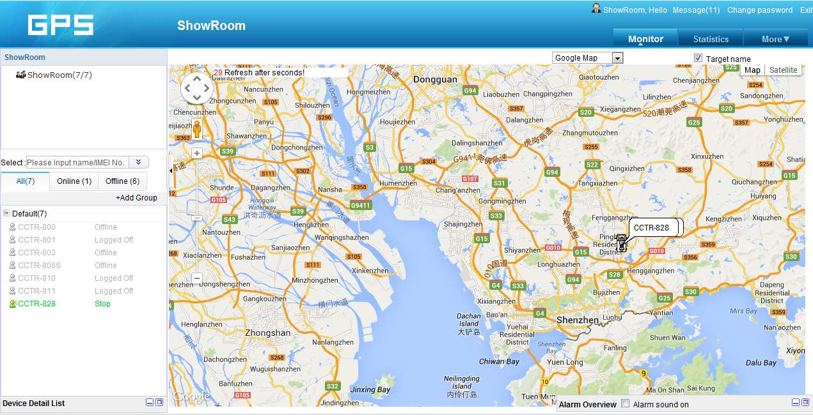

How to Sale a device to a customer
1. Create a new user customer name and login name(Normal is end user, also can be distributor (Sub-distributor)).
2. Select the sold device, and operate the “Sale” or “Move” command to move the selected device to the new created account.
3. Selected the sold device, update expired time / change customer information etc can be operated.
4. The device will be active automatically when the device is powered on and uploading location to platform.

