CCTR-821 Mini Car GPS Tracker Using Guide
Welcome to use this Real Time mini GPS tracker CCTR-821, This product is with GPS module and GSM module, It is mini design for cars, truck, bus, rent vehicle, etc. it has wide working voltage (9-40V), so it can suit for the 12V or 24V vehicle, it can upload current location to website, display history tracking on website, also it has Google map link locate function without platform, also it built in shock sensor to control power saving, shock & move alarm, over area alarm, over speed alarm, etc.
User visit the website www.999gps.net with the applied user’s name and password (Given by us) through any computer with available internet, and without downloaded any software. And it can help to arrange the whole fleet or the vehicles of company or group or personal vehicles with the anti-hijack function.
And also user can download Android app software to android mobile phone, click the app, logon with user name and password, you can locate current location & display history tracking, the user name and password is same with the website login. Using mobile phone visit http://wap.999gps.net also can locate current location, Send SMS or call the tracker, the tracker will send back the current location Google map link by SMS.
This GPS tracker can be used as car alarm, fleet management, driver management etc, it can be used for tracking cars, company vehicles, buses, taxis, trucks, moving equipments, transportations, etc.



iPhone App Download QR Code Android App Download QR Code



Manual(Word) Download QR Code Manual(Pdf) Download QR Code

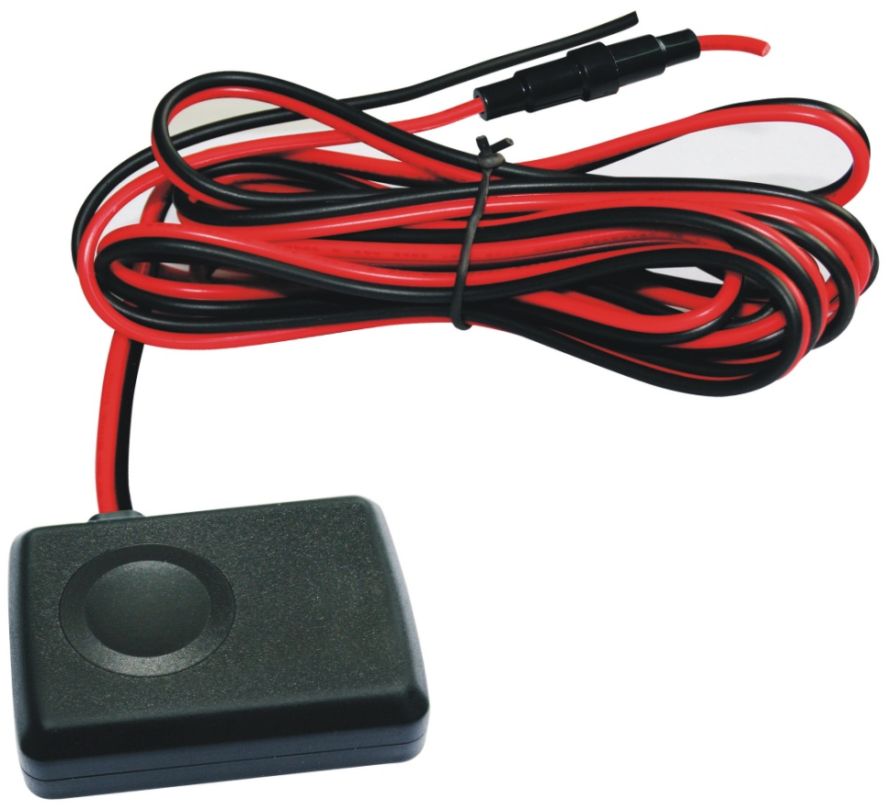
Packing list
Connect 9-V Power
RED: VCC (Battery + )
BLACK: GND or Car Body

This Side face to sky
Please don’t face to ground

CCTR-821
Specification
- Universal 4 GSM Band for Global;
- Wide Range Working Voltage: 9-40V DC;
- GPS Locate, GPRS Upload Location to Server;
- SMS Reply Current Location Google Map Link;
- Built in Shock Sensor for Car Move and Shock Alarm;
Before Using
- Power ON / OFF
    - When power is OFF, connect the tracker power line to car battery, the tracker will power on automatically.
    - When power is ON, disconnect the wire from power or remove the fuse on the RED wire, the tracker will power OFF.
- Install SIM card
Unfasten the screw on the back case of the tracker, and open the case of the tracker , the SIM card holder will be seen, pull the metal cover to “OPEN” direction, and the cover can be opened up, and put the SIM card in the holder (Metal pin face to down), close the metal cover and push the metal cover to “LOCK” direction, after a sound of lock the SIM card has been locked and installed.
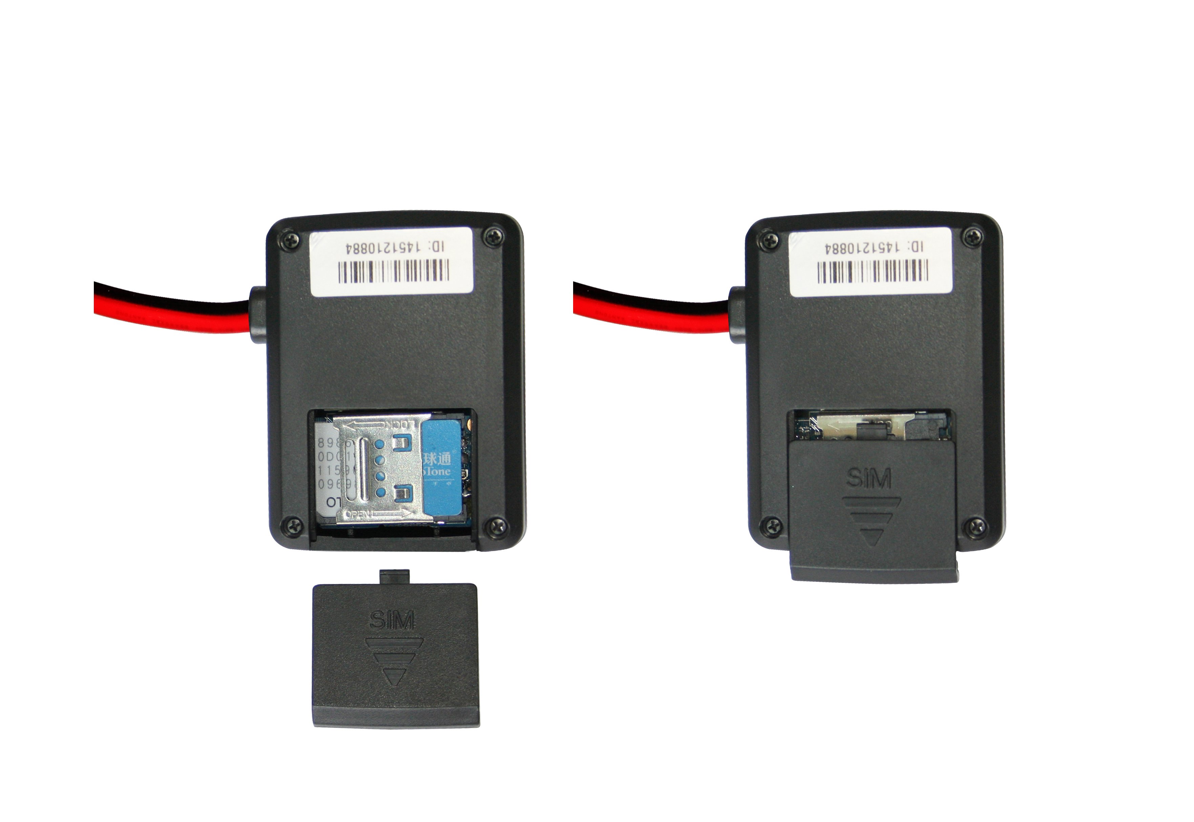

LOCK
Open SIM Card
Room Cover OPEN

Note: 1. This tracker use 2G GSM network, and it upload tracking only through GPRS, it can not work in CDMA network or 3G(WCDMA or CDMA2000) network. (Some 3G SIM card can use in 2G GSM network, this kind of 3G SIM card can use in this tracker)
2. Please confirm the PIN code of the SIM card is disabled (insert the SIM card to mobile phone and can be disabled in mobile phone setting menu).
3. Before installing or uninstalling the SIM card, please power off the tracker.
- ANTENNA
- The Antenna of GSM and GPS are built in the tracker.
- Pleas leave the tracker away from big metal, this will reduce the GSM and GPS signal. And the GPS antenna need faced to heaven, otherwise the GPS signal will be weak and maybe can not located.
- Using Condition
The working temperature is -20 ⁰C to 60 ⁰C, over this range the specification maybe can not reach the standard level, the storage temperature can reach to -40 ⁰C to 80 ⁰C.
- Back to factory setting (Default configuration)
First send SMS (pw,123456,center,yourphonenumber#) to the tracker to set your mobile phone number as center or slave center number, then sending SMS (factory#) to the tracker will delete all user setting and back to factory configuration and repower on.
Notes: After back to default set, all IP / APN / GPRS / Language / Timezone / Alarm Setting etc are deleted and back to factory setting, just like a new product, all preset phone number are deleted and password change to 123456, all the alarm setting is canceled, if the IP/APN/GPRS name & password/TIMEZONE are changed, and you need set these again by sending SMS.

How to Install
1. Connect the RED and BLACK wires to car battery, the tracker will power on automatically, the tracking uploading is controlled by shock sensor, if the tracker begin to move, the tracker begin upload the tracking, if the tracker stop moving, then the tracker will stop upload the tracking , and go to standby mode, the platform will display offline.
RED---------- 9-40V Battery +
BALCK------ GND (Car Body)
- Installation Place on the vehicle
The tracker should be installed in the hidden place, then it is not easy to be broken and removed, because the GPS & GSM antenna are built in the tracker, so you should confirm the installation place have good GPS and GSM signal, the GPS antenna should face to sky, and it can not face to ground, please keep the tracker away from the big metal, we recommend install the tracker under the front panel of the car, or under the rear panel or under the rear glass, or in the pillar beside the driver seat etc. And please fasten the tracker to the car body with adhesive tape or other tape, and keep away from the other auto accessory.
- Upload tracking control
Connect the RED and BLACK wires to car battery, the tracker will power on automatically, the tracking upload is controlled by shock sensor, if the tracker begin to move, the tracker begin upload the tracking, the tracker status on the platform will change to online immediately. if the tracker stop moving, then the tracker will stop upload the tracking , after 10 minutes the tracker status on the platform will change to offline. If you like to keep the tracker always online, send SMS to change the setting is OK, but this will exhaust more data charge and car battery power.

How to Use
- First to buy a 2G GSM phone SIM card, which needs SMS service and incoming caller ID display and GPRS function, and please disable the PIN code of the SIM card, this SIM card phone number is the tracker number and all the operations (calling and sending SMS) to the tracker is this number.
- After install the SIM card to tracker, connect the tracker to car battery to power on the tracker, send SMS to tracker to set your mobile phone number as center or slave center number (pw,123456,center,yourphonenumber#) , then you can use your mobile phone to send SMS to change the setting of the tracker or control the tracker.
Only the center or slave center number can send SMS or call the tracker to change the setting of the tracker or control the tracker.
- After set the center number, park the car in the open place (indoor or underground can not receive the GPS signal), send SMS (Where# or 123#) to tracker with center number, the tracker will reply SMS with Google map link , click the link to visit internet, the map will display on your mobile phone. This means the GPS and GSM is working.
4. Upload the tracking to internet server through GPRS also you need set APN etc, send SMS to tracker to set the tracker SIM card APN / GPRS user name & password / Plmn number etc.
apn,xxx#
apn,xxx,plmn,yyy#
apn,xxx,user,uuu,pd,ppp,plmn,yyy#
xxxis apn name, yyy is the tracker SIM card mobile company code, uuu is GPRS user name, ppp is GPRS password, if you can not confirm this, please search on internet or call your tracker SIM card mobile company to confirm.
Some mobile phone APN and GPRS user name & password has been preset in the device, if the device can not upload location to platform please try to reset the APN name and GPRS user name & password, the APN name and GPRS user name & password please call your tracker SIM card supplier mobile phone company to confirm this.
- After set all the above, check the LED flash on the tracker, if the LED flash slow, it is means all setting is OK, please note that, the tracker will reply message to indicate the setting is success or fault, if no reply SMS message, it means the command is not right or have some other problem.
- After complete the setting, visit the website www.999gps.net, logon with given user nam and password (user name is the last 7 digital number of the tracker’s ID number, the default password is same with user name, for example ID is 1451217388, the default logon name and password all are 1217388, the ID is print on the label on the back of the device, user can change the password and user information after logon, but can not change the user name, our administrator or dealer can change the user name by user request (ask your dealer to contact us), After logon, click the car you want check, the current location will display on the Google map, check the date and time and location is right or not, if it is correct, then you have installed the tracker and set the tracker properly, and it work well.
- If you have many vehicles , we can create a user that can see all your trackers after you login, this can be used as fleet management, ask your dealer to contact us to get your administrator user name and password of your fleet.
- The data & time of the tracker upload to the website is GMT time (Greenwich Mean Time, add or minus a fixed digit is your local time), you can change the display time to your local time by setting the time zone to your local time zone in the menu of My Account after logon the platform ( For example newyork time zone is -05), please refer the platform operation guide.

Command Instruction
Only center or slave center number can send SMS to control or change the setting of the the tracker, the alarm SMS will send to center and slave center number, but the alarm calling only call to center number, so please send SMS to tracker to set the center or slave center number first.
- Set center and slave center number.
Send SMS “pw,123456,center,13987654321#” to the tracker to set center number, Send SMS “pw,123456,slave,13912345678#” to the tracker to set slave center number,123456 is the tracker default password, 139817654321 and 13912345678 are your personal mobile phone number, the tracker will reply set center or slave number OK. If the tracker has no reply, please check the tracker work properly and confirm the SMS command is right.
- SMS locate tracker
Send SMS “url#” or “123” to the tracker, the tracker will reply a google link or text location description of current location to user by SMS, user click the link to visit website, the current location will display on the google map. If the tracker has no reply, please check the tracker work properly and confirm the SMS command is right.
http://maps.google.com/maps?q=N22.6775,E114.1518
Call the tracker with center or slave center number, you can hear will ring, a few seconds later after the tracker hang up the calling , the tracker will reply the location same wit the above.
- Arm and Disarm the Car (Enable or Disable Alarm System)
Send SMS “fortify,0#” (disable the alarm function) or “fortify,1#” (enable alarm function) to the tracker to set car enable alarm or disable the alarm system, after enable the alarm system, continuously shock will trigger the tracker shock alarm, it will notice the center number by making call 6 times, and also it will send SMS to center and slave center number to warning the car owner.the tracker will reply set fortify OK. If the tracker has no reply, please check the tracker work properly and confirm the SMS command is right.
- Stop alarming
Send SMS “alarm#” to the tracker will stop this alarming and back to arm state (stop make calling to center number, start detect shock sensor again,and car is still in alarm state), the tracker will reply stop alarm OK, but if the shock sensor is still trigger, the tracker will keep alarming. If the tracker has no reply, please check the tracker work properly and confirm the SMS command is right.
- Delete center and slave center number.
Send SMS “pw,123456,center,d#” to the tracker to delete center number, and Send SMS “pw,123456,slave,d#” to the tracker to delete slave center number,123456 is the tracker default password, the tracker will reply delete center or slave number OK. If the tracker has no reply, please check the tracker work properly and confirm the SMS command is right.
A: only 1 center and 1 salve center number can be set.
B: Set new center and slave center number can replace the old number.
- Change the tracker password.
This password is different with the platform login password, it is the password of the tracker, it is only used to control tracker by sending SMS or calling to the tracker. Send SMS “pw,123321#” to the tracker to change the tracker password, 123321 is the new password of the tracker (The default password of the tracker is 123456), only center or slave center can change the password. the tracker will reply change password OK. If the tracker has no reply, please check the tracker work properly and confirm the SMS command is right.
- Check the tracker setting
Send SMS “check#” to the tracker, the tracker will reply the setting of the tracker by SMS. If the tracker has no reply, please check the tracker work properly and confirm the SMS command is right.
For example the tracker reply SMS:
SN:9876543210 IP:58.64.155.133 Port:8011
Interval:10,upload:20,sleep:10,alarm:10;
SN: 9876543210; Tracker ID number.
IP:58.64.155.133:8011; Server IP and port.
Upload:30; Upload time interval, default is 30 seconds
Sleep:10; Sleep interval time, unit is minutes (0-1800)
interval:10; ACC off auto arm delay time, unit is minutes (1-60)
- Set tracker sleep time
Send SMS “sleep,10#” (time unit is minutes, from 10-1800, 0 means no sleep) to the tracker to set the sleep time, normally when the tracker stop moving ,the tracker will keep online and not go to sleep, but for some cold place or in the winter, the car battery capacity is very small, let the tracker go to sleep after stop moving can save battery power, and this can avoid the car battery run out, the tracker will reply set sleep time OK. If the tracker has no reply, please check the tracker work properly and confirm the SMS command is right.
- Set tracker sleep out time
Send SMS “sleepout,0#” (time unit is minutes, from 0-1800, 0 means no sleepout) to the tracker to set the sleepout time, after set sleepout time, the tracker will back to online every interval time and sleep again, this can keep the tracker update the location every interval time. the tracker will reply set sleepout time OK. If the tracker has no reply, please check the tracker work properly and confirm the SMS command is right.
- Set shock sensor time
Send SMS “motion,5#” (time unit is seconds, from 1-10, default is 5) to the tracker to set the shock sensor trigger time, the upload is trigger by shock sensor, only continuously moving can trigger shock sensor, set the shock sensor time longer will make the shock sensitivity lower. the tracker will reply set sleepout time OK. If the tracker has no reply, please check the tracker work properly and confirm the SMS command is right.
Note: don’t set shock sensor time too small, it is easy to trigger the tracker alarming or uploading tracking to the server even the tracker do not move.
- Re-power on tracker
Send SMS “reset#” to tracker can make the tracker power off and power on again, some time the tracker can not online, send the reset command, the tracker will re-power on a few minutes later.
- Restore to factory setting (Back to Default)
Send SMS “factory#” to the tracker, the tracker will delete all user setting, and restore all setting to factory mode, just like a new tracker, and the tracker will repower on after delete user setting. If the user have changed the setting, such as APN, IP, center number, etc, you need set this again after back to factory mode.

Platform Operation Please Refer Platform Operation Guide

Notes:
  - Please confirm that the SIM card PIN code has been disabled, it means if mobile phone use this SIM card, it is not necessary to input any password. Otherwise the tracker can not find GSM network, the Green LED will keep ON .
  - This tracker use 2G GSM network, and it upload tracking only through 2G GPRS, it can not work in CDMA network or 3G(WCDMA or CDMA2000) network, if the 3G SIM card can use in 2G GSM network, then the SIM card can be used in this tracker.
  - The antenna of GSM and GPS is built in tracker, please note that the install location of the tracker must can receive the GPS signal, normally the back of the seat or arm rest box or under the back window or room on the panel etc. please leave away the tracker from big metal, and keep away from the magnetic components.
  - The GPS need 10-200 seconds to locate the position, when the GSM signal is weak or the network is very busy, the SMS maybe delay to send by the GSM network, this is normal.
  - The tracking data on our server will keep 6-12 months, the old data will be deleted.

Trouble Shooting
      - The tracker auto power off: please confirm the tracker power supply is connect properly and confirm the fuse is OK .
      - After power on the tracker, the tracker RED LED keep on, and it has not any repose, and no ring, please confirm the SIM card has been installed properly, the SIM card PIN code is disable, and the SIM card has enough charge, and the mobile phone can work well in that place. If the tracker work well the Green LED will flash once every 4 seconds.
      - If the tracker can not upload location to website, please confirm the SIM card GPRS function is enabled, and the APN or GPRS username & password have been set properly (call the mobile phone to confirm the APN & GPRS username and password). if the tracker do not move, the tracker will not upload tracking, try moving the tracker.
      - If the tracker can not send back information by SMS, please confirm the SIM card has ID caller display function and SMS service function, and you have set the center or slave center number (only center or slave center number can send SMS), and please read the SMS information of the tracker sending back, and check the instruction & password is right or not.
      - Can not login the platform: use SMS to check the ID of the tracker, and try it again, if not success please contact us.
      - After go out the under ground park, some tracking will lost, the GSM and GPS module will take a few minutes to receive signal and re-locate, some tracking maybe lost, this is normal.
      - Some time some location point is lost, this is normal, in the transmit process, some point maybe is lost, but this will not happen very often.

Specification:
GSM Module | MTK | GPS Module | MTK
GSM Frequency | 850/900/1800/1900Mhz (4 Band) | GPS channel | 32 channels
GSM / GPS Antenna | Built in | Locate precision | 10-20 Meters
GPS Cold Start Time | 36 seconds | GPS Hot Start Time | 1 second
Working Voltage | 9-40V DC | Standby Current | < 10 mA
Uploading Current | <200mA / 5V | Working Temperature | -20 ⁰C to +55 ⁰C
Absolute Temperature | -35 ⁰C to +70 ⁰C | Storage Temperature | -40 ⁰C to +80 ⁰C

Warranty
This system has been tested before sold. We strongly recommend you to get this system installed by professional. There is a one-year warranty except the following condition:
1. Installed, fixed, or changed by personally or unprofessional.
2. Warranty will eliminate if the ownership of the tracker has been changed.
3. Parts damaged by man-made.
4. Battery, adapter, wires, etc.
Warning: this device is just a auxiliary product that applying the location of current object, we have not any responsibility if you have damage or lost in using this tracker.
Customer
User Mobile Phone |  | Tracker SIM card
Date | Year month day
Model | CCTR-821 | Serial Number
Distributor
Notes: The explanation of this manual is belonged to our company, some small changes may not notice customer, if you have any problem please contact us, thanks !

